**What is Terraform :-** **Terraform is an infrastructure as code tool that lets you build, change, and version cloud and on-prem resources safely and efficiently.**

**Why Terraform:- We can use Terraform to efficiently deploy, release, scale, and monitor infrastructure for multi-tier applications**

**Benefits of Terraform:- Collaboration and Access Control.**

**Collaboration and Access Control.**

**Remote State Management.**

**Version Control Integration.**

**Asssingnment 1:-**

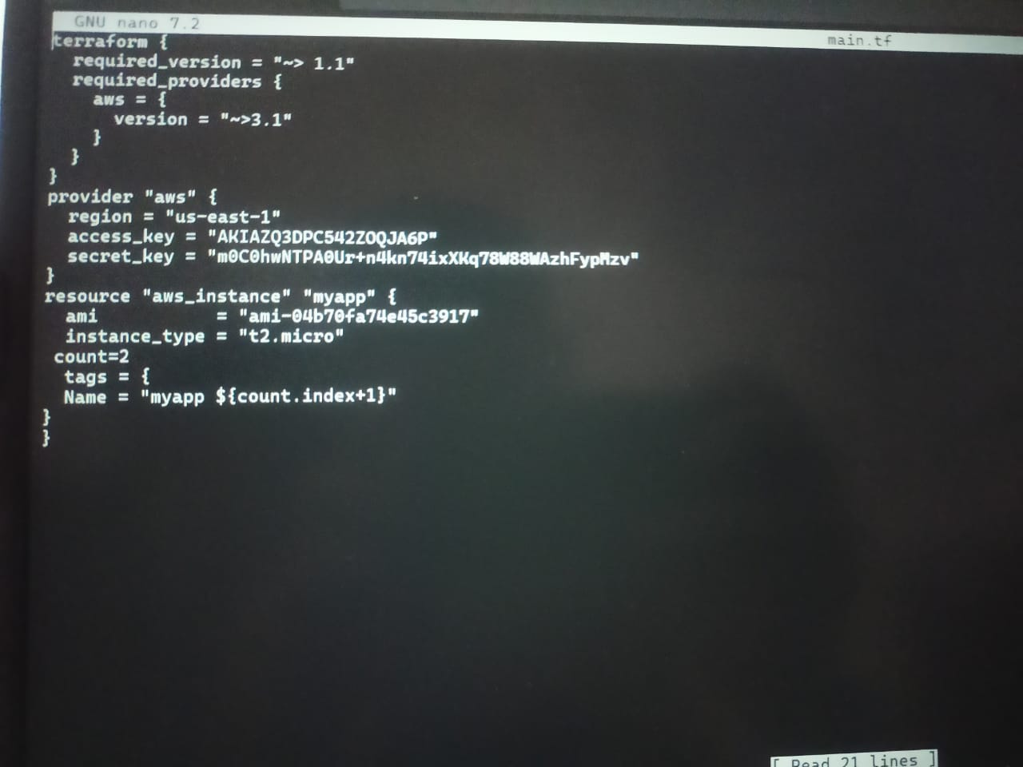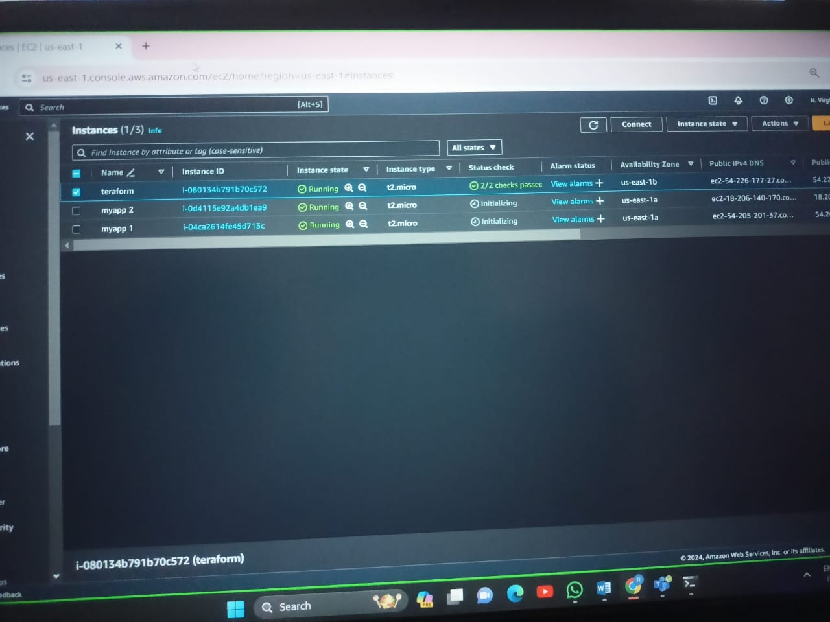

**ASSINGMENT 2-**